**Incline Elementary School: 2023-2024**

**Welcome to grade 1!**

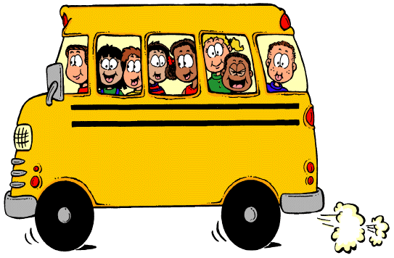

***To Bring to School Every Day***

* Backpack
* Lunch or lunch money or completed Free and Reduced Meal waiver
* Appropriate outdoor clothing (snow pants, jackets, gloves…)
* A **healthy** snack every day
* Spill proof water bottle

***Classroom Supplies for the First Day of School***

* A pack of large pink erasers
* a set of 24 Crayola brand crayons (it really helps if all students have the same colors)
* 6 or more large glue sticks
* a package of black dry eraser markers
* Headphones that go over the head with a cord (if you would like to purchase a second set in case they break that would be appreciated!)
* Gallon sized zip loc bags
* A box of tissues
* A tray of watercolor paint (crayola is great, the crazy art ones are not very pigmented)

***School Fees***

Here is our school fee structure. Please make checks payable to “Incline Elementary School”:

|  |  |  |
| --- | --- | --- |
| Technology Fee | Provides your student with access to classroom technology | $20 |
| Classroom Fee | Provides your student with additional classroom supplies and activities | $40 |
| **Total Fee\*** |  | **$60** |

* Fees may be waived for families qualifying for Free and Reduced Meal plans. Please come to the main office to complete your FRM forms.

**Have a fantastic school year!**